MEMORÍA PRÁCTICA 5

FUNDAMENTOS FISICOS DE LA INFORMATICA

LUIS ORTIZ FERNÁNDEZ

Practica 5

Ejercicio 1:

|  |  |
| --- | --- |
| Valor nominal | Valor experimental |
| 𝑉= 4,5 V | 𝑉 = 4,755 $±$ 0,05 V |

|  |  |  |
| --- | --- | --- |
| Chip | Modelo concreto | Familia lógica(TTL/CMOS) |
| 74**08 (AND) | 74LSO8N | TTL |
| 74**32 (OR) | 74LS32N | TTL |
| 74**86 (XOR) | 74LS86N | TTL |

[Datasheet 74LSO8N](https://pdf1.alldatasheet.es/datasheet-pdf/view/12616/ONSEMI/SN74LS08.html)

[Datasheet 74LS32N](https://pdf1.alldatasheet.es/datasheet-pdf/view/12649/ONSEMI/SN74LS32.html)

[Datasheet 74LS86N](https://pdf1.alldatasheet.es/datasheet-pdf/view/12662/ONSEMI/SN74LS86.html)

|  |  |
| --- | --- |
| Valor extremo característico | Tensión(V) |
| VIH(min) | 2.0 V |
| VIL(max) | 0.8 V |
| VOH(min) | 2.7 V |
| V OL(máx) | 0.5 V |

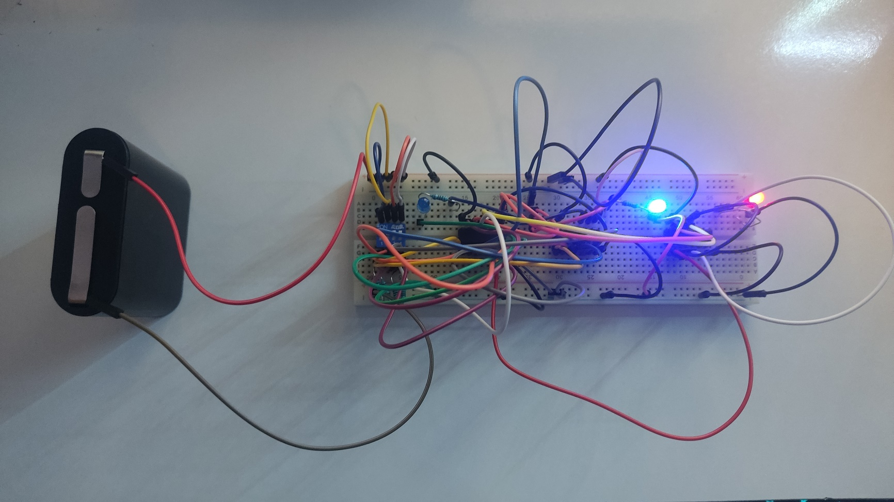Ejercicio 2:

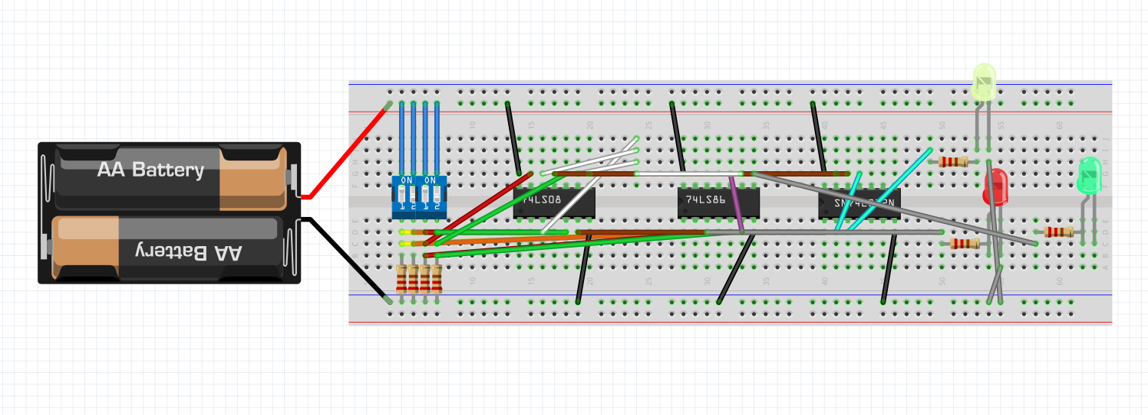

|  |  |  |  |  |
| --- | --- | --- | --- | --- |
|  | Tensión (V) | Valor | Rango válido | ¿Dentro del rango? (S/N) |
| Interruptor cerrado | 1.713 $±$ 0,02 V | H | [VIH(mín),5 V] | S |
| Interruptor abierto | 0,02 $±$ 0,002 V | L | [0 V, VIL(máx)] | S |

|  |  |  |  |  |
| --- | --- | --- | --- | --- |
|  | Tensión (V) | Valor | Rango válido | ¿Dentro del rango? (S/N) |
| Interruptor cerrado | 4.46 $±$ 0,05 V | H | [VIH(mín),5 V] | S |
| Interruptor abierto | 0,01 $±$ 0,001 V | L | [0 V, VIL(máx)] | S |

Luis Ortiz Fernández